**GAIN**

**PAIN**

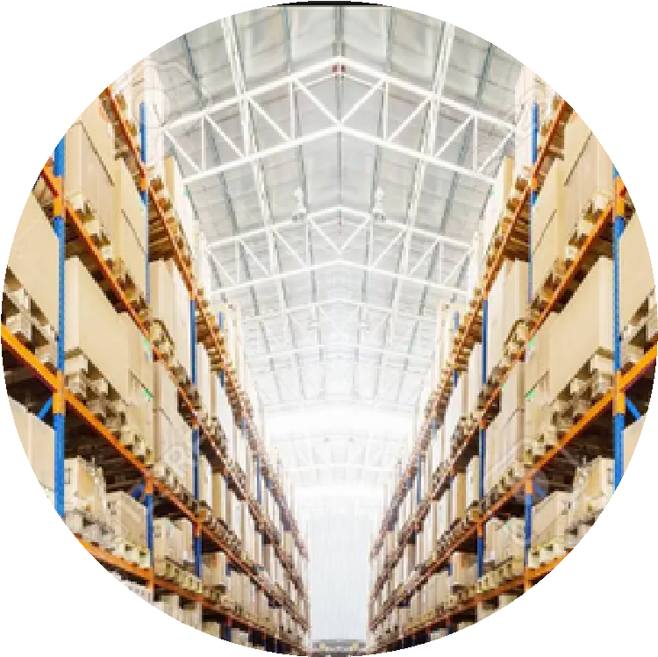

**When will the**

**goods arrive**

**Whether they**

**provide estimation**

**time**

**Whether the**

**charges are fixed**

**or not**

**Whether the**

**listed items are**

**in detail**

**If the goods arrive at**

**time**

**Does the goods have**

**any damage**

**How can I manage if**

**the goods is not**

**deliver on the time**

**Whether the right**

**goods are arrived and**

**the needed amount of**

**goods arrived**

**Provide the**

**information about**

**the quantity of goods**

**needed**

**Collect the receipt of**

**the goods arrived**

**Compare the goods**

**price and quality**

**with other kind of**

**platforms**

**Nervous if the goods**

**is not delivered on**

**time**

**Curiosity with the**

**goods**

**Bindly trusted on the**

**quoted goods**



**Goods are affected**

**by disaster**

**management**

**Utilization of goods**

**used wisely**



**Expenses of goods**

**may rises**

**Supply on demand**